Covid-19 Safety Plan – Mid Island Co-op Retails – November 3, 2020

Risk
- The HSE manager will review the Covid-19 risk daily so that Co-op remains aware of positive and negative trends. Mid Island Co-op will follow the recommendations on BC Mistry of health and adhere to the recommendations outlined by WorkSafeBC

Social Distancing

Personal Space and Work Areas

- Staff must maintain a physical distance of at least 6 feet between themselves, customers, suppliers, and contractors.
- Only one employee is permitted behind the POS area at one time.
- Only one customer is permitted to process payment at the main POS area at one time
- Sneeze barriers will be installed between the clerk and customer at the POS area
- Only one employee is permitted in the site office at one time.
- No more than two employees are permitted in the backrooms at one time. At some retails, to maintain social distancing, only one employee may be permitted in the backroom.
- Employees are encouraged to kindly remind co-workers and customers to stand back or remain at least 6 feet apart if social distancing expectations are not adhered to.

Note: Due to the size, Mid Island Liquor Parksville is permitted two have two tills operational with two employees behind the POS area, and 3 employees in the backroom/backstock area.

Number of Customers Permitted in the Retail at one Time

The number of customers permitted in the retail at one time is to be calculated by the site manager and approved by the operations manager and HSE manger prior to implementation.

Calculation and Maintaining the Maximum Number of People in a Retail to Support Physical Distancing:
- It is challenging to calculate the number of people that can be in a store while practicing physical distancing. Nevertheless, it is critical to evaluate how many people can reasonably be in a store and easily practice physical distancing of 2 metres between people to reduce the spread of COVID-19.
- It is strongly recommended that food retail and grocery store operators have 5 square metres of unencumbered retail floor space per person, i.e. 5 square metres/person.
- This unencumbered space would be retail floor space minus floor space used for fittings, displays etc. o Take, for example, a store with 200 square metres of retail floor space with 70 square metres of fittings/displays. (*See the example below using feet.) The store has 200 square metres - 70 square metres = 130 square metres of unencumbered floor space for customers. o Maximum number of people allowed in the store to support physical distancing would be: (130 square metres) / (5 square metres/person) = 26 people.
- Monitor the number of customers and staff entering and leaving the store. Once the maximum number of persons for a store is reached, allow one person in for every person that leaves. Separate incoming and outgoing customer flows if possible.
- Evaluate whether people can easily practice physical distancing with the calculated number of people in the store. Evaluate specific areas of the store where it may be a challenge to practice physical distancing.
- Consider asking customers about their experience of physical distancing in the store and how to improve the ability to practice physical distancing within and outside the store.
*Using the same example as above, but using feet instead of meters, a store has 2153 sq. ft retail floor space with 753 sq. ft of fittings/displays. The store has 2153 sq. ft- 753 sq. ft = 1400 sq. ft of unencumbered floor space for customers. Using 53.8 sq. ft of unencumbered floor space per person, the maximum number of people allowed in the store to support physical distancing would be: 1400 sq. ft÷ (53.8 sq. ft/person) = 26 people.

Social Distancing Signage
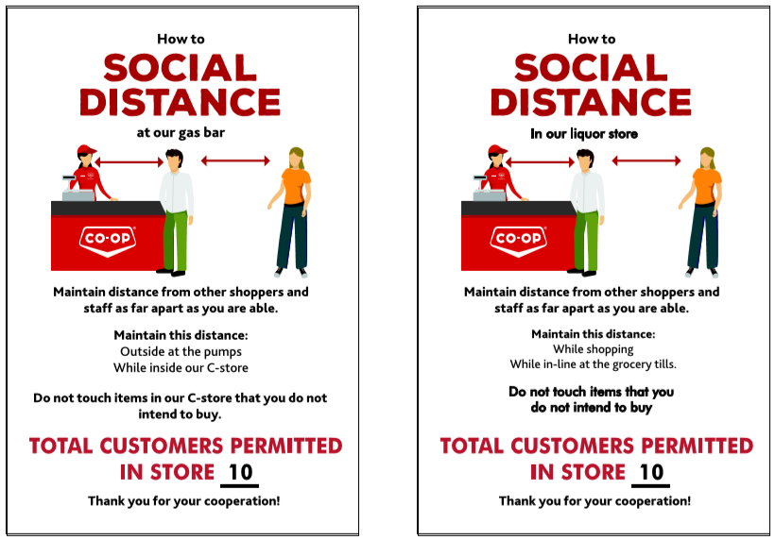
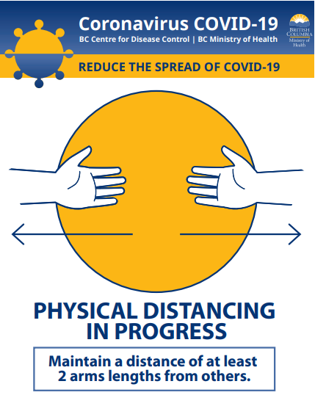
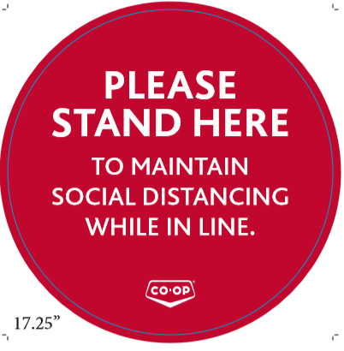
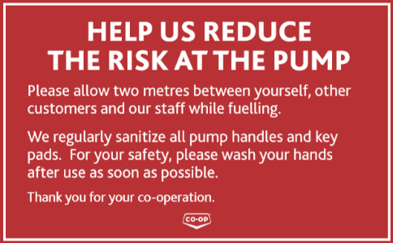

- Post the BC Ministry of Health’s physical distancing poster on each site communication board or an area that is in plain view for all staff.
- A sandwich board will be placed outside at the front doors of each retail will include physical distancing information for customers.
- Social distancing blades will be placed throughout each retail to remind staff and customers to remain 6 feet apart.
- Circular floor markings will be placed in the store near the POS counter to help customers adhere to social distancing expectations. Tape lines will be placed outside the front doors to help direct lineups in a safe direction and customers remain at least 6 feet apart.
- Signage will be placed on the top of all pumps reminding customers to adhere to social distancing guidelines.

Exposure to Contractors
- Only critical work shall take place by contractors until further notice.
- If work by a contractor has been permitted by the operations manager, the Co-op employee managing the contractor must meet with the contractor to review the contractor and Co-op’s Covid-19 Safety Plan. The controls outlined in both Safety Plans must be adhered to.
- Within reason, contract work shall take place outside Co-op working hours.

Surface Contamination

Frequent Disinfecting
- Additional sanitizing products should be kept on hand to accommodate increased sanitizing, delayed shipping, or lack of availability.
- Zep FS Supermarket cleaner will be used to sanitize and prevent the spread of Covid-19.
- The manufacturers recommendations must be followed when using the product and the safety data sheet must be readily available.
- Employees must have the appropriate WHIMIS training and product specific training prior to using the sanitizing product.
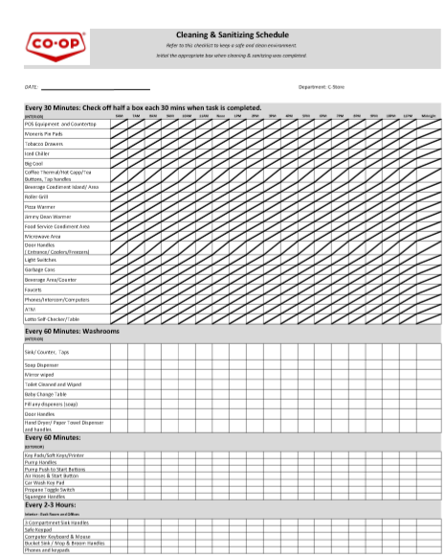
- Sanitizing frequency at all retail sites must take place at least once per hour and will include all high-risk surfaces. I.e. pay point, fridge & freezer door handles washrooms etc. A schedule below will be utilized to track the items and when they were sanitized.

Hygiene
- Employees are required to wash or sanitize their hands after handing cash, loyalty cards, credit cards etc.
- Employees are required to wash their hands frequently. This includes upon arrival to work, before after using the washroom, before and after eating and after moving about the office etc.
- Avoid touching your eyes, nose, and mouth with unwashed hands.
- When you feel a cough or sneeze coming on, cover your mouth and nose with a tissue. Don't have a tissue? Cough or sneeze into your upper sleeve or elbow, not your hands. Wash your hands right away after you sneeze, cough or touch used tissues or masks. Throw used tissues into the trash.
- Post the BC Ministry of Health Covid-19 prevention poster will be posted on the communication bulletin board.
- Post the BC Ministry of Health handwashing poster in the staff washroom and coffee/food prep areas.
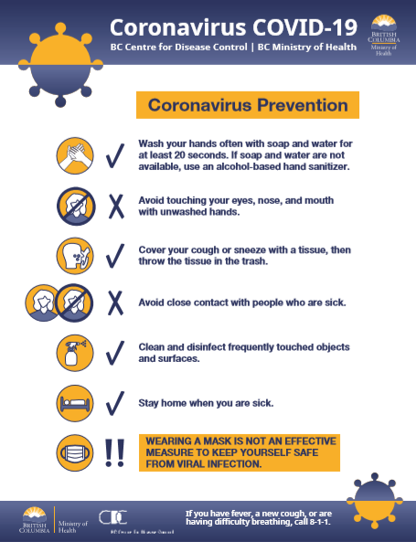
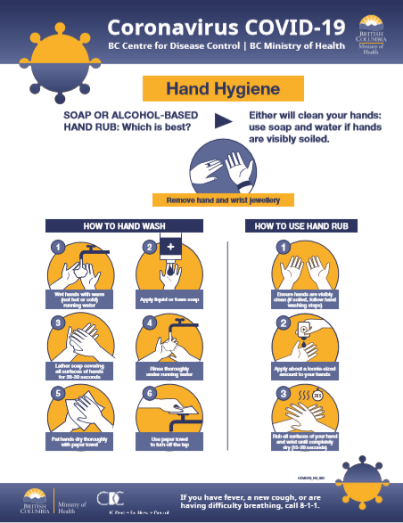

PPE
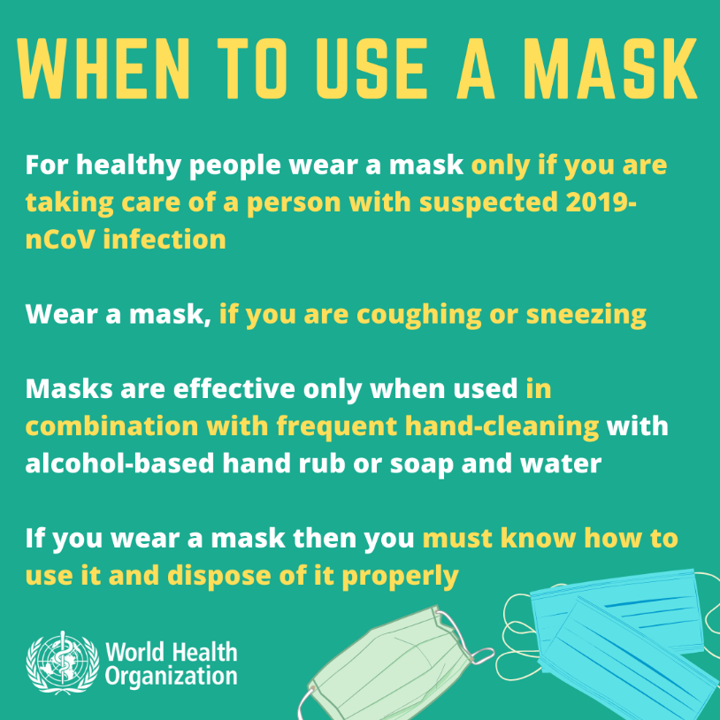
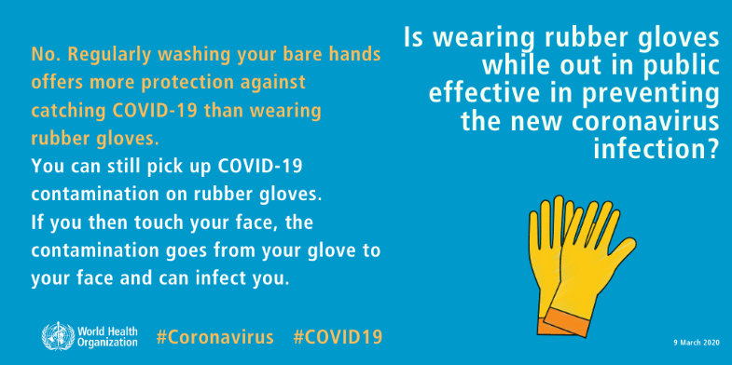
- Staff are not permitted to wear gloves or a mask as a form of protection against contracting Covid-19

Food Safety
- Open food and beverage counter areas are closed to customers and will be served to customers by Co-op staff.

Sickness / Covid-19 Symptoms
- Pay attention to your health and how you are feeling. If you are sick, stay home
- If you are sick and have Covid-19 symptoms, take the BC Covid-19 Self-Assessment or contact 811.

- Anyone who is sick or showing symptoms of Covid-19 is prohibited from the workplace, this include:
- Anyone who has had symptoms of Covid-19 in the last 10 days. Symptoms include fever, shills, new or worsening cough, shortness of breath, sore throat, and new muscle aches or headaches.
- Anyone directed by Public Health to self-isolate.
- Anyone who has arrived from outside Canada or who has had contact with a confirmed Covid-19 case must self-isolate for 14 days and monitor for symptoms.

Employees who start to feel ill while at work
- The employee will be asked to wash or sanitize their hands.
- The employee will be asked to put on a mask.
- The employee will be asked to go straight home and complete the Covid-19 Self-Assessment Tool or call 811 for further guidance related to testing and self-isolation.
- If the employee is severely ill (e.g., difficulty breathing, chest pain), call 911.
- Clean and disinfect any surfaces that the ill worker has come into contact with.
- Refer to the CRS Covid-19 toolkit for further information on how to respond to a confirmed Covid-19 case at a retail.

Calculating the number of people permitted in the store
*Using the same example as above, but using feet instead of metres, a store has 2153 sq ft retail floor space with 753 sq ft of fittings/displays. The store has 2153 sq ft- 753 sq ft = 1400 sq ft of unencumbered floor space for customers. Using 53.8 sq ft of unencumbered floor space per person, the maximum number of people allowed in the store to support physical distancing would be: 1400 sq ft÷ (53.8 sq ft/person) = 26 people.

Site Specific Details or Additional Controls:

Notes: ________________________________________________________________________________________________________________________________________________________________________________________________________________________________________________________________________________________________________________________________________________________________________________________________________________________________________________________________________________________________________________________________________________________________________________________________________________________________________________________________________________________________________

Employee Name | Employee Signature | Date Reviewed

